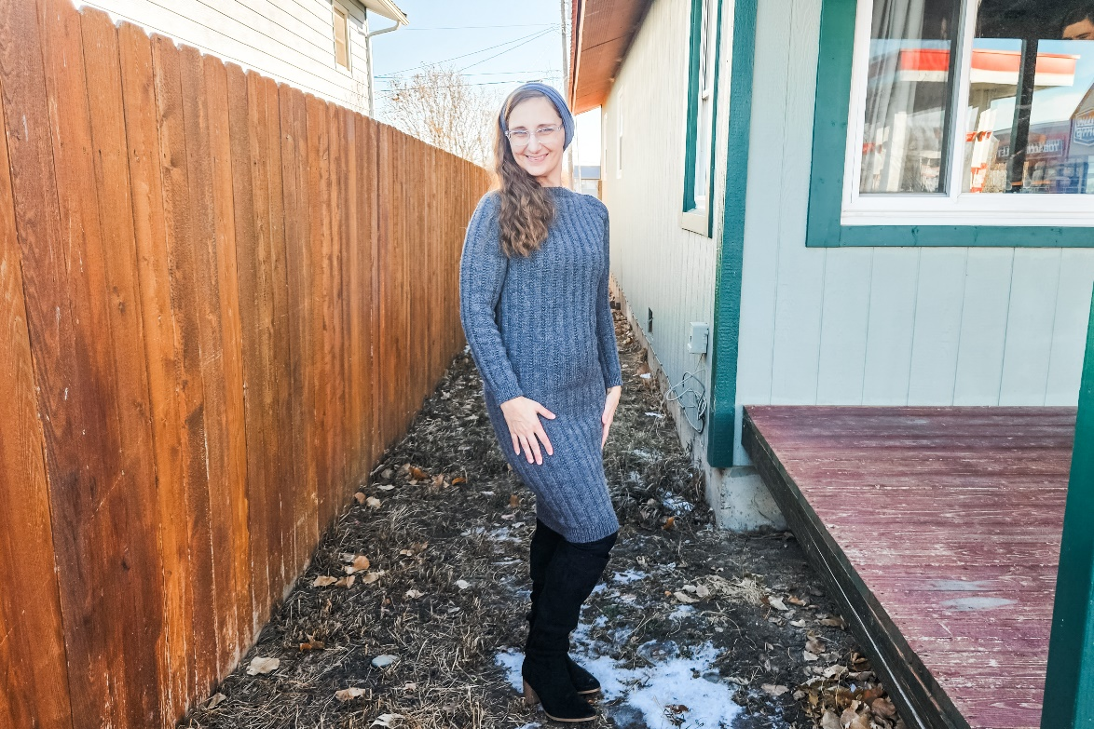

MATERIALS AND INFO
Size: XS, S (M, L) 1X, 2X (3X, 4X)
Materials: Approximately 7, 7 (8, 8) 9, 10 (11, 13) hanks of Berroco Vintage Worsted (218y/100g)
Needle Size: 7(US) 4.5mm circular needles and dpn, 6(US) 4mm circular and dpn
Gauge (tension): 22sts & 28 rows to make 10cm square, using size 7(US) 4.5mm needles working in stockinette stitch
Chest Measurement: 74, 78 (82, 90) 98, 107 (119, 131) cm/29.25, 30.75 (32.25, 35.5) 38.5, 42.25 (46.75, 51.5) in

METHOD
This pattern is a crew-neck raglan worked in the round from the top down. The sleeves are held and then picked up and worked in the round. The main body/skirt is knit in a 6-stitch rib while the edges are worked in a 1x1 rib pattern. The skirt length can be customized for desired fit. Lengths listed are for just under the knee. When adjusting length be sure to take into account extra yardage when adding length.

1X1 RIB PATTERN
1×1 Rib: [K1, P1] repeat around.

RAGLAN INCREASES
Raglan Increase Round – [K2, M1L, work to 2 sts before next marker, M1R, k2, sm] repeat 3 more times, then work to end of round. 8 sts increased.

MICHAEL RIB
Round 1 – knit around
Round 2 – (p2, k4) around

YOKE
Cast on using U.S. 6 circular needle: 88, 92 (96, 100) 100, 104 (108, 116) sts.
Join in the round, taking care not to twist, and place a beginning-of-round marker.
Work in 1x1 rib for 2.5cms/1in

Set up row – [k38, 38 (40, 42) 44, 46 (48, 52)], pm, [k6, 8 (8, 8) 6, 6 (6, 6)] pm, [k38, 38 (40, 42) 44, 46 (48, 52)], pm, [k6, 8 (8, 8) 6, 6 (6, 6)]
Start working Michael Rib now with a round 1.

RAGLAN SHAPING ROWS/ROUNDS
Work raglan increases as described above
every round 0, 0 (0, 0) 0, 0 (6, 12)
then every other round 14, 15 (16, 19) 29, 31 (30, 28) times,
then every 4th round 6, 6 (6, 5) 0, 0 (0, 0) times
working the Michael rib as follows:

Maintain the established Michael Rib pattern between raglan increases, using the size-specific stitches listed below to keep the rib aligned.

After the m1l on the front/back
XS – k4, Work in Michael rib across
S – k4, Work in Michael rib across
M – k2, Work in Michael rib across
L – k3, Work in Michael rib across
1X – k1, Work in Michael rib across
2X – k2, Work in Michael rib across
3X – Work in Michael rib across
4X – k2, Work in Michael rib across

After the m1l on the sleeves
XS – k2
S – k4
M – k1, p2, k1
L – k4
1X – p2
2X – k2
3X – p2
4X – k2

Then work 3 rounds without increases

STITCH COUNT CHECK
Once all the raglan increases have been completed you will have 248, 260 (272, 292) 332, 352 (396, 436) sts on your needles divided as follows:
78, 80 (84, 90) 102, 108 (120, 132) sts (front),
46, 50 (52, 56) 64, 68 (78, 86) sts (sleeve),
78, 80 (84, 90) 102, 108 (120, 132) sts (back),
46, 50 (52, 56) 64, 68 (78, 86) sts (sleeve)

DIVIDE FOR SLEEVES
Remove markers as you get to them.
Knit across the front sts, place the next 46, 50 (52, 56) 64, 68 (78, 86) sts on a holder or waste yarn (right sleeve), cast on using the backwards loop method 6, 10 (6, 6) 6, 6 (6, 6) sts (right underarm), knit 78, 80 (84, 90) 102, 108 (120, 132) sts (back), place the next 46, 50 (52, 56) 64, 68 (78, 86) sts on a holder or waste yarn (left sleeve), cast on using the backwards loop method 6, 10 (6, 6) 6, 6 (6, 6) sts (left underarm), knit to beginning of round marker. 168, 180 (180, 192) 216, 228 (252, 276) sts

BODY AND SKIRT
Continue in Michael Rib until the piece measures 70, 70.5 (71, 71.5) 72, 72.5 (73, 73.5) cm/27.5, 27.75 (28, 28.25) 28.25, 28.5 (28.75, 29) in from the underarm, or to desired length.
Switch to smaller circular needle.
Work in 1x1 rib for 4 cms/1.5in.
Bind off all sts in pattern.

SLEEVES
Keeping in established Michael Rib pattern, work each sleeve one at a time as follows: Pick up 4sts from underarm, knit 46, 50 (52, 56) 64, 68 (78, 86) sts of the sleeve on the holder, pick up 4sts from underarm on to U.S. 7 double pointed needles, place marker at center underarm to keep track of the beginning of round. 54, 58 (60, 64) 72, 76 (86, 94) sts

Work 17, 17 (17, 17) 19, 19 (19, 19) rounds in pattern.

DECREASES
Decrease 1 st at each side of marker as follows:
Every 14th round 4, 5 (5, 0) 0, 0 (0, 0) times,
then every 12th round 4, 2 (3, 3) 0, 0 (0, 0) times,
then every 10th round 0, 0 (0, 7) 0, 2 (0, 0) times,
then every 8th round 0, 0 (0, 0) 7, 11 (0, 0) times,
then every 6th round 0, 0 (0, 0) 7, 0 (16, 15) times,
then every 4th round 0, 0 (0, 0) 0, 0 (2, 4) times.
38, 44 (44, 44) 44, 50 (50, 56) sts remain.

Continue without decreasing in stripe pattern until sleeve measures 39, 39.5 (40, 40.5) 41.5, 42 (43, 43) cm/15.25, 15.5 (15.75, 16) 16.25, 16.5 (17, 17) in (or desired length) measuring from underarm.

CUFF
Switch to smaller DPNs. Work in K1P1 ribbing for 4 cm / 1.5 in. Bind off in pattern.

FINISHING
Weave in all ends and block as desired.

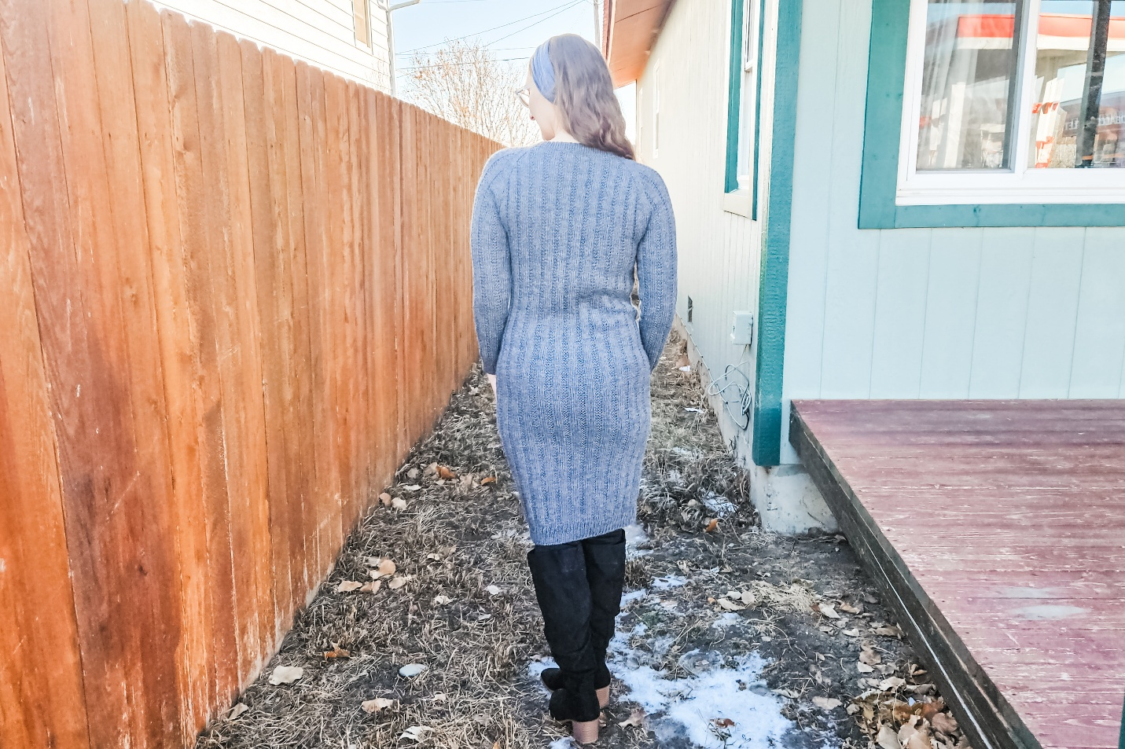

ABBREVIATIONS
k - knit
k2tog -knit 2 stitches together
m1l – pick up from front to back the strand between the 2sts on your needles, knit through back loop
m1r – pick up from back to front the strand between the 2sts on your needles, knit through the front loop
P – purl
pm – place marker
sm – slip marker
ssk – slip next st knitwise, slip next st knitwise, place stitches back onto left needle, knit both slipped sts together
st – stitch
sts – stitches

